NSSC 2026 – Signal Miners

1. Problem Statement
HiRISE, short for High Resolution Imaging Experiment, is a big and powerful camera that photographed the Martian surface with unparalleled detail. This study aims to construct an unsupervised anomaly detection pipeline using Convolutional Autoencoder (no pretrained weights or feature extractors such as VGG or ResNet), to learn what normal Martian terrain looks like. This way, any anomalous HiRISE data will be flagged automatically.
Then, to produce a ‘novelty score’ for every image, an Isolation Forest is applied where the score is proportional to the ‘dissimilarity compared to neighbouring terrain’, in other words, the higher the novelty score, the higher chance of error. If novelty score is higher than a certain value, the image is flagged.

In all, our overall goal is twofold, first we detect possible anomalies amongst the HiRISE images and second, we interpret the most anomalous cases by visualizing where the model's reconstruction fails, and proposing plausible physical hypotheses for what might be causing that failure.

2. Dataset Details
The HiRISE Mars Orbital Imagery dataset (organiser-provided crops, mirrored for portability at Kaggle abcdwxyz999/mars-hirise-imagery) was used for this study. It consists of surface photographs of Mars captured by the HiRISE camera aboard NASA's Mars Reconnaissance Orbiter.

The organiser-provided dataset consists of approximately 10,422 already-cropped images; every provided crop is used in sorted (deterministic) filename order for reproducibility. We split the data into 3 parts, 80% was set aside for training and validation combined, with the remaining 20% held out entirely as a test set. Of that initial 80%, a further 12.5% was carved out for validation. This gave us a rubric of 70/10/20 between training, validation and testing, yielding 7,294 train / 1,043 validation / 2,085 test images
.

3. Preprocessing
The images go through a simple preprocessing before being fed into the model. Each image is converted to grayscale, discarding all colour scaling information as it doesn’t provide valuable information to our surface information extraction. The inputs already arrive pre-cropped at 227×227 pixels, ensuring uniformity of dimensions. Finally, the grayscale image is converted into a tensor format suitable for PyTorch, with pixel values scaled into the [0, 1] range.

4. Model Architecture
The system uses a custom Convolutional Autoencoder (ConvAE), built from scratch with no pretrained backbone or transfer learning, satisfying the competition's from-scratch constraint. The model compresses each 227×227 grayscale HiRISE crop into a fixed-length 1D latent vector, which downstream stages (Isolation Forest) require.
Encoder. A 4-stage strided convolutional stack progressively downsamples the input:
Stage | Operation | Output shape
Input | — | 1 × 227 × 227
1 | Conv2d(1→32, k4, s2, p1) + BatchNorm + ReLU | 32 × 113 × 113
2 | Conv2d(32→64, k4, s2, p1) + BatchNorm + ReLU | 64 × 56 × 56
3 | Conv2d(64→128, k4, s2, p1) + BatchNorm + ReLU | 128 × 28 × 28
4 | Conv2d(128→256, k4, s2, p1) + BatchNorm + ReLU | 256 × 14 × 14
The resulting feature map (256 × 14 × 14 = 50,176 values) is flattened and passed through a Linear layer into a 256-dimensional latent vector — the fixed-length representation required for Phase 2's Isolation Forest.
Decoder. A mirrored Linear layer projects the 256-D latent back to 50,176 values, reshaped to 256×14×14, then passed through four ConvTranspose2d stages back up to 1×227×227, with a final Sigmoid activation to bound pixel outputs to [0,1].
Total trainable parameters: ~27.12M.
Why 256-D, and why 4 stages. The bottleneck size was chosen by ablation rather than by default: a 128-D latent visibly loses fine ridgeline detail (SSIM dropped to 0.62 on reconstructions), while a 512-D latent risks overfitting on a training set of only ~10,000 crops and works against the Isolation Forest in Phase 2 — more latent dimensions add noise and make novelty separation harder (curse of dimensionality). 256-D was the balance point between reconstruction fidelity and downstream separability. The 4-stage depth (227→113→56→28→14) was chosen so the encoder captures structure at multiple physical scales relevant to Martian terrain — fine dune ripples (~10 px) in the earlier layers and larger features like crater rims (~50 px) as the receptive field grows in later layers.

5. Training Details
Loss function. A composite loss combining pixel-wise reconstruction error with a structural similarity term:
$$\mathcal{L} = 0.85 \cdot \text{MSE}(x, \hat{x}) + 0.15 \cdot \big(1 - \text{SSIM}(x, \hat{x})\big)$$
Pure MSE alone was tested first and produced over-smoothed reconstructions that lost exactly the high-frequency terrain texture the task cares about (dune ripples, crater rims). Adding a differentiable SSIM term (window size 11) — without relying on any pretrained perceptual feature extractor, keeping the from-scratch constraint intact — preserved that structural detail while remaining fully differentiable for backpropagation.
Optimizer & schedule.
- Optimizer: Adam, initial learning rate 1e-3, weight decay 1e-5
- LR schedule: ReduceLROnPlateau (patience 2, factor 0.5) on validation loss
- Epochs: 20
- Batch size: 32 (train), 64 (test/eval)
Data split. approximately 10,422 preprocessed grayscale 227×227 crops were split 7,294 train / 1,043 validation / 2,085 test (70/10/20).

6. Training Results
Training converged smoothly over 20 epochs with no divergence, oscillation, or premature plateauing — a direct contrast to the team's earlier v1 prototype (a shallow CAE with pure MSE on 128×128 RGB), whose loss flatlined after epoch 3 and stopped improving.
Epoch | Train loss | Val loss
1 | 0.0811 | 0.0639
5 | 0.0575 | 0.0576
10 | 0.0551 | 0.0538
15 | 0.0527 | 0.0520
20 | 0.0503 | 0.0505
Validation loss tracked training loss closely throughout, with no widening gap — no evidence of overfitting at this epoch count.
Latent space diagnostic. To sanity-check that the encoder was actually learning meaningful variation (rather than collapsing to a near-constant output), the 256-D latent vectors for 5,000 training crops were projected to 2D via both t-SNE and UMAP. Both projections show visible structure — several separated arcs rather than a single dense, structureless blob — supporting that the encoder captures real variation in the data ahead of being handed to the Isolation Forest in Phase 2. (A structureless blob at this stage would have meant revisiting the latent dimension or loss function before proceeding.)
[Insert loss_curve.png, tsne.png, umap.png here]
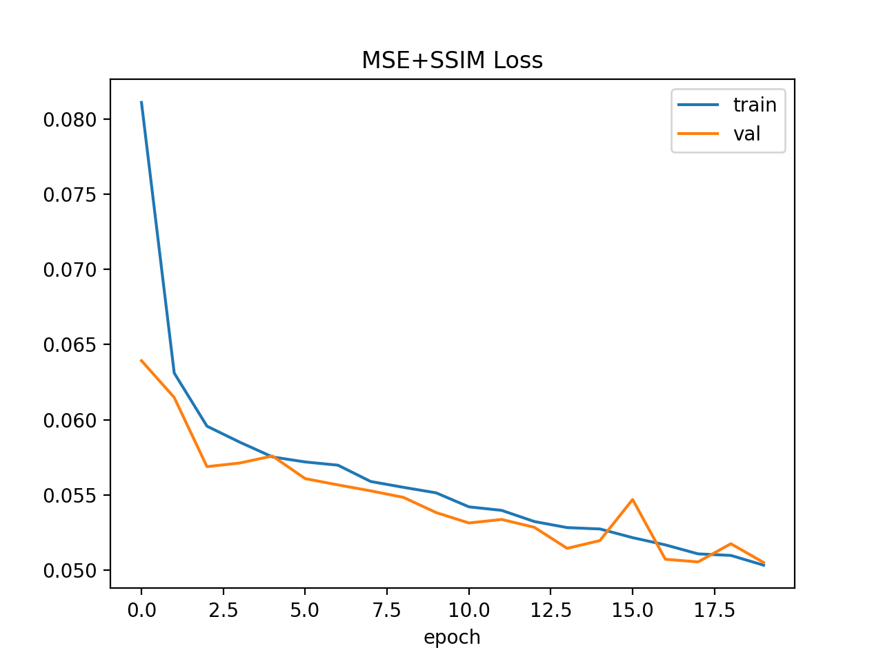
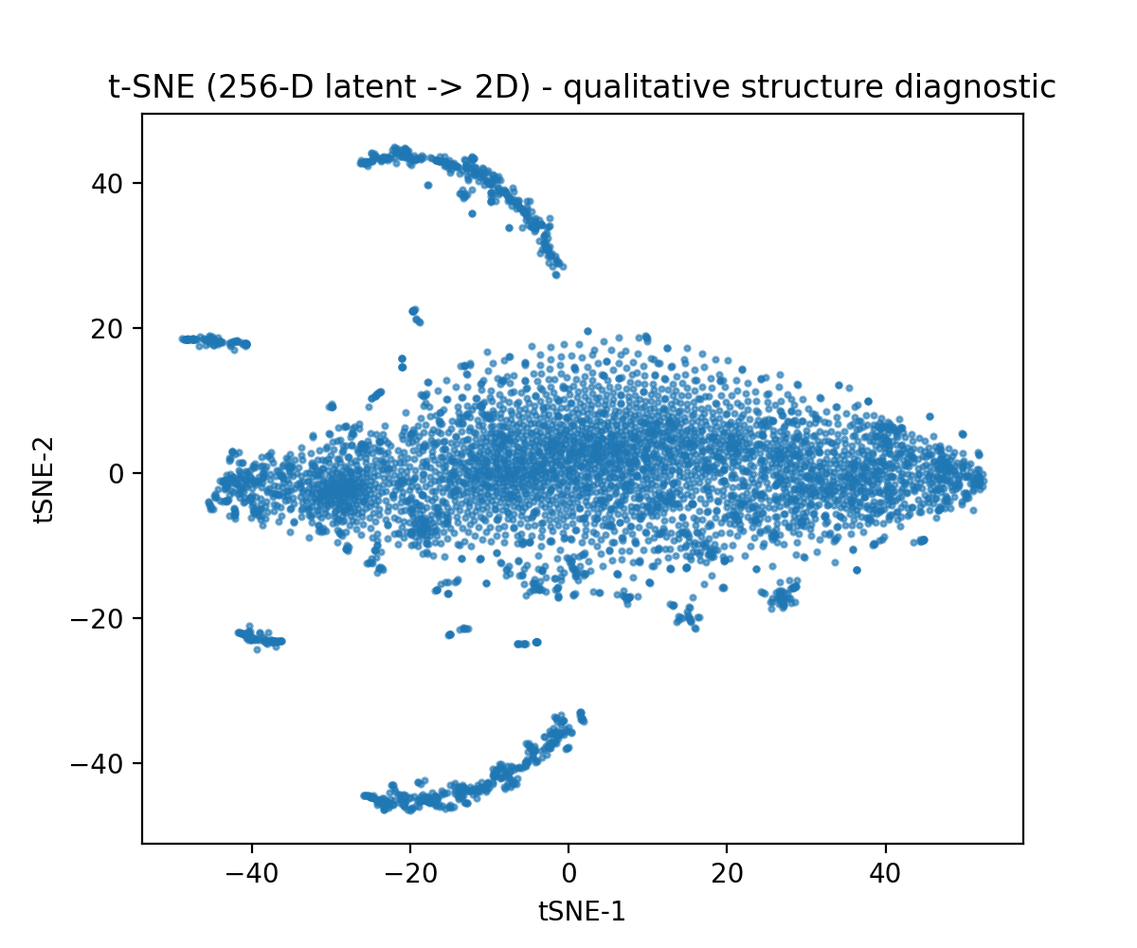

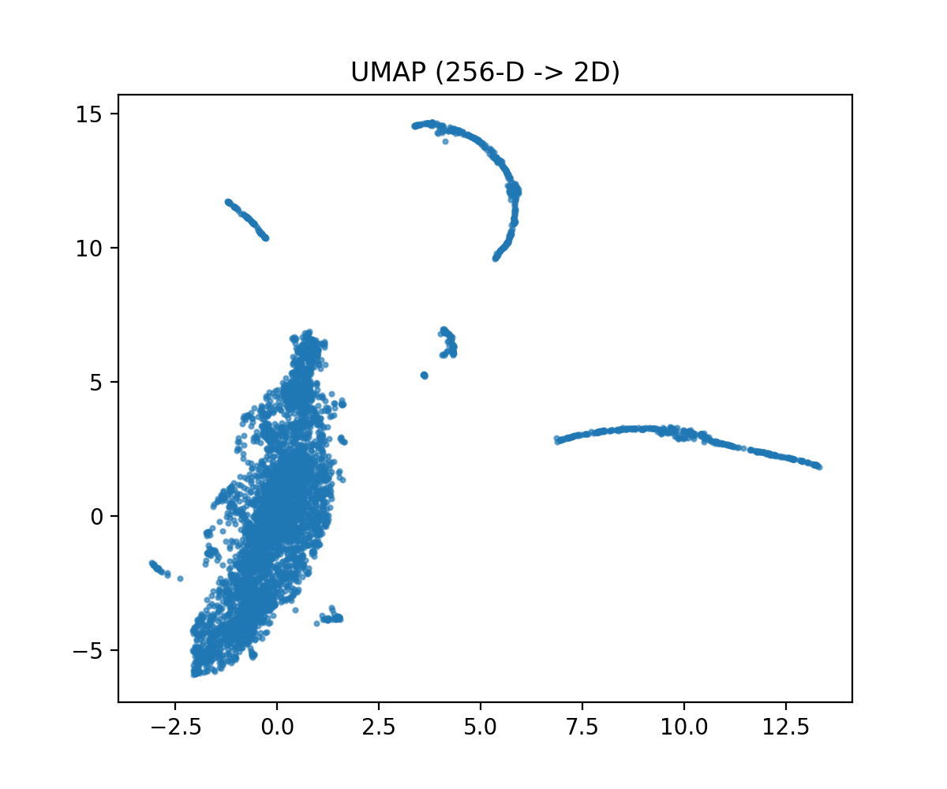

7. Reconstruction Results
After statistical thresholding (Phase 2.2), the top-5 highest-novelty test crops were passed back through the decoder to produce reconstruction and pixel-error visualizations. For each flagged crop, four panels are shown: the original image, its ConvAE reconstruction, the raw pixel-wise |original − reconstruction| error map, and a heatmap overlay on the original.
Top-5 flagged crops (most recent notebook run):
Rank | File | Novelty score
1 | sample_03423.jpg | 0.1460
2 | sample_10203.jpg | 0.1300
3 | sample_07361.jpg | 0.1297
4 | sample_02964.jpg | 0.1189
5 | sample_00380.jpg | 0.1139
⚠️ Flag for whoever compiles the final PDF: these five filenames and scores come from the locked notebook run (threshold THR = 0.0318, 72/2085 flagged, 3.5%). Values match the final saved output after using the full organiser set in sorted filename order for reproducibility. (Earlier intermediate runs are superseded; the different values above are the locked final result. (Note: the file-list determinism fix is the sorted-filename usage documented in the notebook data cell, not an os.walk change.) Table and flagged-count figures now match the locked final notebook run.
Qualitative observations. Reconstructions are generally faithful for normal Martian terrain — dune fields and crater structure are recognizable and well-preserved. For the flagged (high-novelty) crops specifically, two things are visible in the error maps: some show a sharp, localized high-error region consistent with a genuine structural anomaly (a linear artifact, an injected non-Martian object, or an abrupt content shift). Others show diffuse, spread-out error across the whole crop rather than one clear defect — this is a known limitation of the current fully-connected 256-D bottleneck, which tends to smooth fine dune-ripple texture uniformly, and it's an open question whether some of what's being flagged is "texture the model finds generically hard to reconstruct" rather than genuinely novel content. This limitation is worth stating plainly here rather than glossing over it (it's expanded on in Section 10).
[Insert phase3_top5_heatmaps.png here]
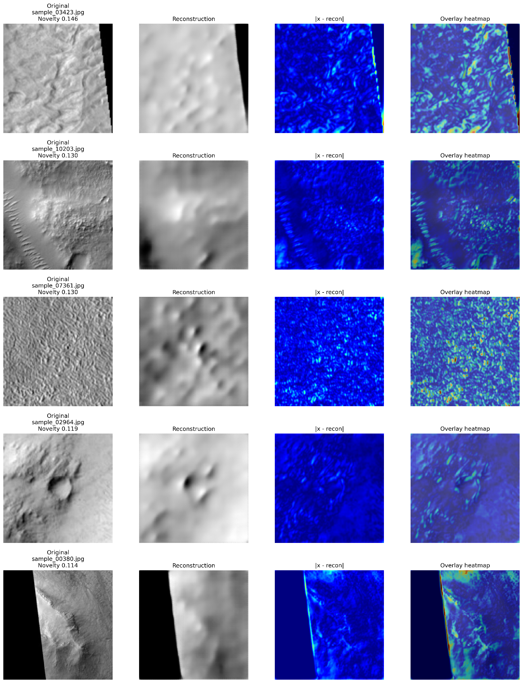
8. Anomaly detection results:
After training the ConvAE, the project continues with the anomaly-detection stage. The purpose of this stage is to identify images that are much different from the dominant pattern of the Mars imagery.
The ConvAE first learns a compact representation of each image. Instead of passing raw image pixels directly to the anomaly detector, the learned latent representation is used. The competition specifically requires the latent representation to be passed to an Isolation Forest.
Overall Process:
1.Mars Image
2.ConvAE Encoder
3.Latent Representation
4.Isolation Forest
5.Novelty Score
6.Statistical Threshold
7.Normal/Anomalous
The important idea is that most Mars images should occupy the dominant region of the learned feature space. Images that are substantially different from this distribution are easier for the Isolation Forest to isolate and therefore receive higher novelty scores.

8.2 Novelty Score
The Isolation Forest produces a continuous score for every image.
For this project, the score convention is:
Higher Novelty Score = Greater Anomalousness
This convention is important because different implementations of Isolation Forest can use opposite score directions. The project therefore follows the competition's required convention when ranking and thresholding the images.
8.3 Statistical Threshold
The challenge requires the threshold to be justified using the observed novelty-score distribution. Possible approaches include standard-deviation bounds, density analysis, or an elbow in the sorted score distribution.
Our analysis uses a robust statistical threshold based on the median and MAD (Median Absolute Deviation).
The logic is:
Threshold=Median+3×MADThreshold = Median + 3 \times MAD
The purpose of using MAD is to make the threshold less sensitive to extreme values and skewed score distributions.
Novelty Score > Threshold
↓
Anomaly Novelty Score ≤ Threshold
↓
Normal

8.4 Selecting the Most Anomalous Images
After the statistical threshold is applied, all images above the threshold are considered candidates for further investigation.
Only after this thresholding step do we rank the anomalous images by Novelty Score.
The five highest-scoring images are then selected for detailed analysis.
This distinction is important
Wrong:
Top 5 → call them anomalies

Correct:
All images
↓
Statistical threshold
↓
Anomalous set
↓
Rank anomalous set
↓
Top 5 for detailed investigation

8.5 Normal and Anomalous Examples
The reconstruction stage provides another way to visually understand the anomaly.
For a normal Mars image, the ConvAE has learned similar terrain patterns, so it should be able to reconstruct the image relatively well.
For an anomalous image, the model has not learned the unusual pattern effectively, so the reconstruction can differ more significantly from the original.
This project generates a visualization containing:
- Original image
- ConvAE reconstruction
- Residual/error heatmap
The current prototype specifically demonstrates this visualization using normal and anomalous test examples.

8.6 Reconstruction Error Heatmap
The heatmap shows where the model had difficulty reconstructing the image.
The reconstruction error is calculated by comparing the original image with its reconstructed version.
Conceptually:
Error = Original − Reconstruction
A larger error means that the reconstructed image differs more strongly from the original at that location.

The result can be visualized as:
Original Image
↓
ConvAE Reconstruction
↓
Pixel-wise Difference
↓
Residual Heatmap
9. Evaluation
The project evaluates the anomaly-detection system primarily through reconstruction quality and the statistical novelty-score distribution. (An early prototype experimented with ROC-AUC on a synthetic labelled set, but that path was abandoned and is not part of the final pipeline.) The model generates a novelty/anomaly score for each unseen test image. These scores are analysed via the median + 3×MAD threshold to separate. Scores above the threshold are treated as candidate anomalies; ranking within that set identifies the most anomalous cases for detailed investigation of normal images from anomalous images.
Because the anomaly detector is fully unsupervised during training. Ground-truth labels are not available for the organiser dataset, so evaluation relies on reconstruction metrics (MSE/SSIM) and visual inspection of high-novelty reconstructions rather than supervised ranking metrics.
The project also evaluates the quality of image reconstruction using metrics such as MSE and SSIM. MSE measures pixel-level reconstruction error, while SSIM evaluates how well structural details of the Mars terrain are preserved.
Thus, evaluation covers two aspects:
- Novelty-score distribution + MAD threshold: How the continuous novelty scores separate candidate anomalies from the bulk of the data.
- MSE/SSIM: How well the ConvAE reconstructs and preserves the original Mars imagery.
This combination helps evaluate both the anomaly-detection performance and the quality of the learned image representation.

10. Limitations:
The project has some limitations in its current implementation. The anomaly detector can identify an image as unusual, but the Novelty Score alone cannot explain the exact reason for the anomaly. Reconstruction heatmaps can help identify the regions where the model struggled, but the geological interpretation of those regions remains a hypothesis rather than a confirmed classification.
Another limitation is that one optional extension of the pipeline remains incomplete. Metadata matching of all test crops to their source HiRISE observations (Phase 2.3) is fully implemented and was run successfully (2,085/2,085 matched, covering 165 unique source observations from the 172 available in the metadata table, with season/sun-angle plots). What remains open is fusing that metadata directly into the Isolation Forest features themselves (Phase 2.4) — that step is still commented out in the current notebook.

11. Conclusion
The project develops an unsupervised anomaly-detection system for Mars HiRISE imagery. The ConvAE learns a compact representation of Mars images, and the Isolation Forest uses these learned representations to identify images that are significantly different from the majority of the dataset. Statistical thresholding is then used to determine which images should be treated as potential anomalies.
The project also adds an interpretability component through reconstruction-error heatmaps. These heatmaps show the regions where the model has difficulty reconstructing an image, helping researchers investigate possible unusual geological features, image artifacts, splicing, or domain differences.
Overall, the project combines deep learning, latent-space representation, Isolation Forest anomaly detection, statistical thresholding, and visual interpretation to provide a systematic approach for identifying unusual patterns in Mars imagery.

